SmartRock PCB Testing and Debugging

Ohm/Voltage Meter

The most important tool used in making sure a board can be used is the voltage meter. Below is an image of one, the lab will have multiple and may look different.

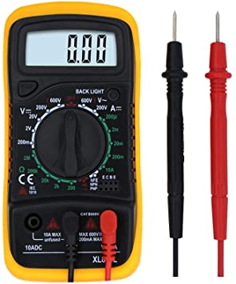

This can be used to check voltages, currents, resistance, capacitance, inductance, diode bias direction, and importantly for our use signal connections. This signal connection tool will have an icon that will resemble an audio icon. Icon 12 on the following multimeter is the icon you want.

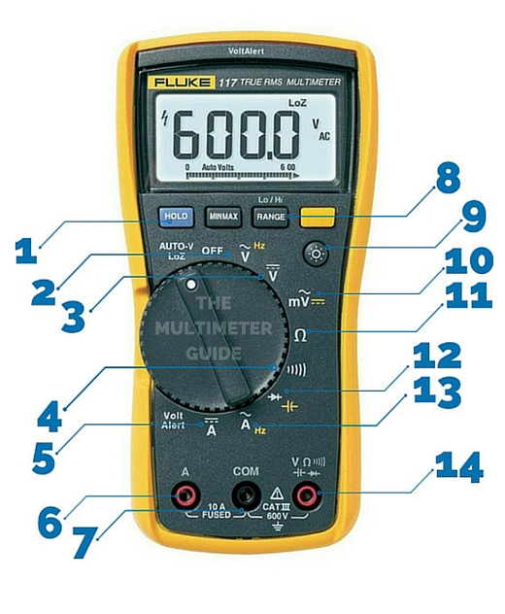

Setting the dial to this setting will cause a noise to be emitted by the tool whenever the two leads (one ground and one high voltage) are touched together. This is useful as now that traces on the PCB can be checked before applying any power to the electronics. Other options on the multimeter dial are also useful and will want to be utilized depending on what needs to be checked or debugged.

First check over – before powering on

There are two very important things to double check before powering on a board, one may fry components if an issue is present. The other isn’t as vital but must be correct for board operation. These tests will use the trace short circuit tool in the multimeter explained above.

Power and Ground

Circled in the circuit are a few contacts for the power and ground of the PCB.

The red circles are the two points for the VCC plane and the light blue circles are the two points for the GND plane. To check that these are working correctly, first put one probe on a red circle and one probe on a light blue circle. If you here a tone from the meter that indicates that these are connected. This is a major issue and the board should NOT be powered on – power in this case could cause some high currents to be conducted shorting components or burning out the controllers. If no tone is made there are no issues here. If there is an issue look at any components that connect to both VCC and GND, something is causing a short in the soldering. Some culprits to check first would be U1, U2, U3, and U4 (the chips), and then the smaller components such as resistors and capacitors as well as the microcontroller headers.

The second test is to put probes on both red and then probes on both light blue. Each one of these tests should have a tone and means the board doesn’t have any major defects in the power planes and all components will most likely be powered correctly. If there is no tone there was a problem in manufacturing. This is fixable but is difficult and unreliable as a product, a new board should just be constructed and used instead.

I2C Lines

Everything in this board utilizes I2C for sensor communication, so making sure these are correctly operating is a useful check. This is good to do before power on but can be done later. Generally, if the code cannot see/sense a sensor that it is supposed to something is wrong with the I2C trace and this check can be done to localize the problem area. The following board diagram will show the points that are connected to the two I2C lines.

The yellowish colored shapes show where the SDA connections and the white shapes show the SCL connections. The checks to make here are similar to the VCC and GND checks made earlier. First probe multiple spots of the yellow circle to make sure they are all connected, then do the same for the white spots. A tone should be made when both probes are on the same color. Then place one probe on each color, if a tone is made that means a short is being made in the solder somewhere. This is a little tricky to track down as there are multiple places this short could be, visual inspection with a microscope will be useful in this instance. Resoldering or taking an exacto knife or razor to the shorted solder may be enough to fix the issue.

Second Test – Power

Now that the important traces are checked the board can be powered on as if it were to be used. Apply the entire stack, i.e. with the hypnos and feather, making sure to supply voltage through the hypnos. Then using the multimeter set the settings to voltage and probe the earlier mentioned VCC and GND (the red and blue circles respectively). There should be a voltage of about 3.3V showing up on the multimeter. The second test is the supply voltage for the EC sensing circuit. Probe the two spots shown below.

The yellow and the white circles are the supply points for the EC circuit. Using the same voltage mode on the multimeter place one probe on each spot, the readout should be either 6.6V or -6.6V. A negative is fine here, it just depends which probe is placed where. The true voltages on these spots are 3.3V and -3.3V volt, but the meter will show them together as a 6.6V. If this is not what is shown then the negative voltage supply has an issue, this is the U2 chip. Check the solder here and make sure all of the surrounding circuitry is soldered correctly.

These are the main checks – other issues will need more detailed and specific debugging. The steps detailed in this document will get the board quickly checked and off the ground for more rigorous testing with code. The next test I would do it connect a feather with an I2C address scanner script to make sure all of the I2C devices are shown – if more info is needed for this step reach out to Cameron Whitlow on basecamp. For other niche debugging questions feel free to reach out as well.